- Create datasource.properties file in resources folder with this context:
guru.username=lmekudishvili
guru.password=Mekuda2002Mfeb
guru.jdbcurl=someUrlForDB
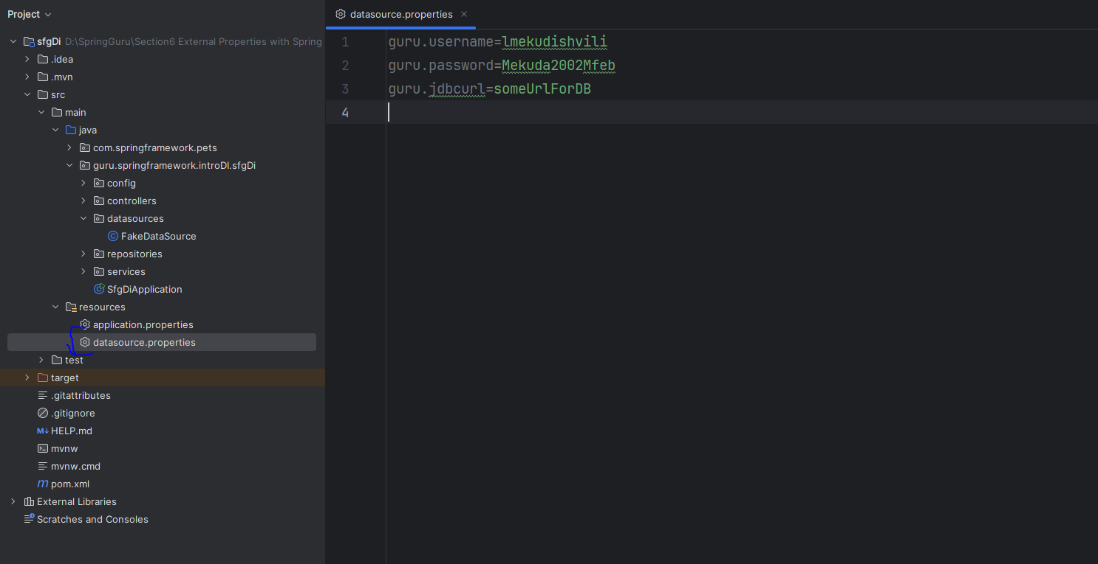
- Create fakeDatasource class where we can define our datasources fields:
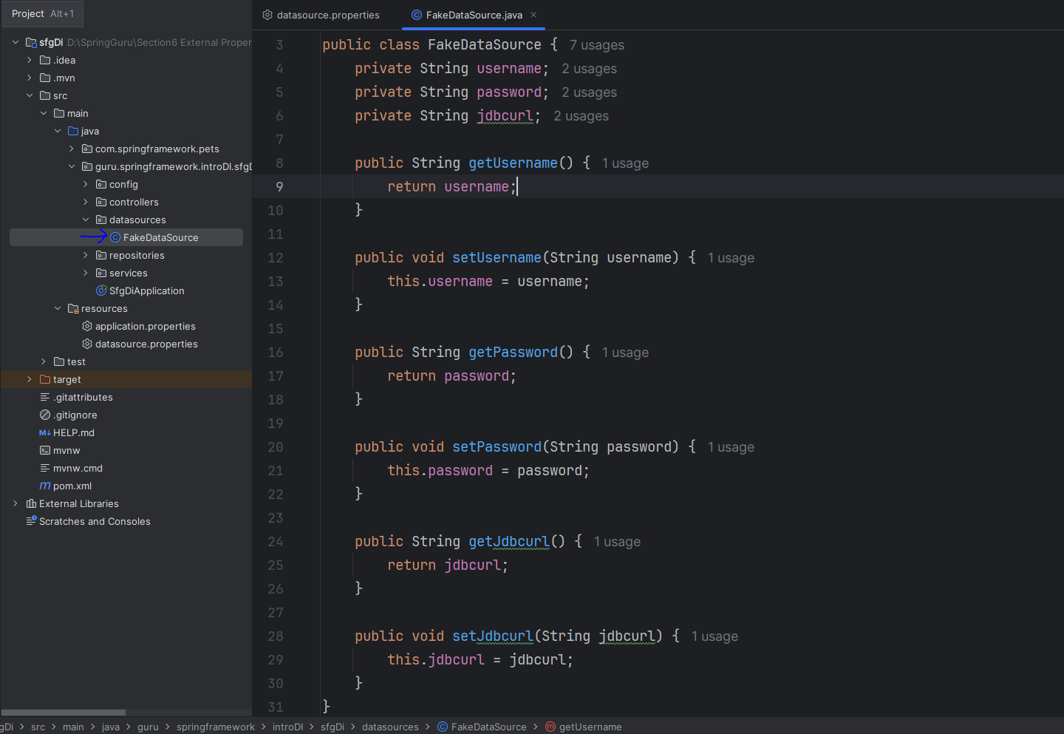

- Create config for spring to create beans using that datasource property and our POJO class:
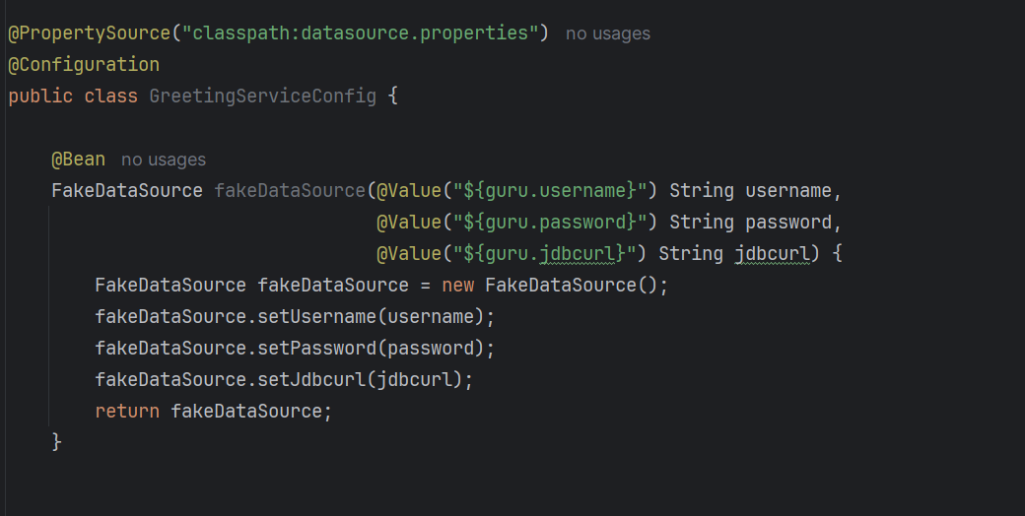
@PropertySource – identifies where datasource property file is located and what’s the name
@Value- gets actual value from what’s the written in curly brackets fields.
- Output of main spring class:
